Field Analyzer User’s Guide

Field Analyzer, like Turf Analyzer, is a standalone software package that is Java based and can be run on virtually any platform that supports Java including Windows, Linux, and Mac operating systems. Field Analyzer is designed to analyze aerial digital images primarily of research plots, but it can also analyze rectangular regions in any field. Prior to analysis with Field Analyzer, images should be rotated such that the field edges are parallel with the screen. There are several software packages that can be used to rotate images including GIMP (www.gimp.com) and Faststone (www.faststone.org).

The types of analysis that Field Analyzer supports are: canopy coverage, dark green color index (or DGCI), thermal infrared (IR), and normalized difference vegetation index (NDVI). The following instructions outline the steps for quantifying canopy coverage, DGCI, IR, and NDVI using Field Analyzer after it has been downloaded and registered. Any questions, problems, or suggestions regarding the program should be directed to turfanalyzer@gmail.com.
Getting started
After double clicking on the Field Analyzer Icon, a window opens directing the user to select the directory and image to be analyzed. Choose the image for analysis and the image is imported to Field Analyzer as shown in Figure 1:

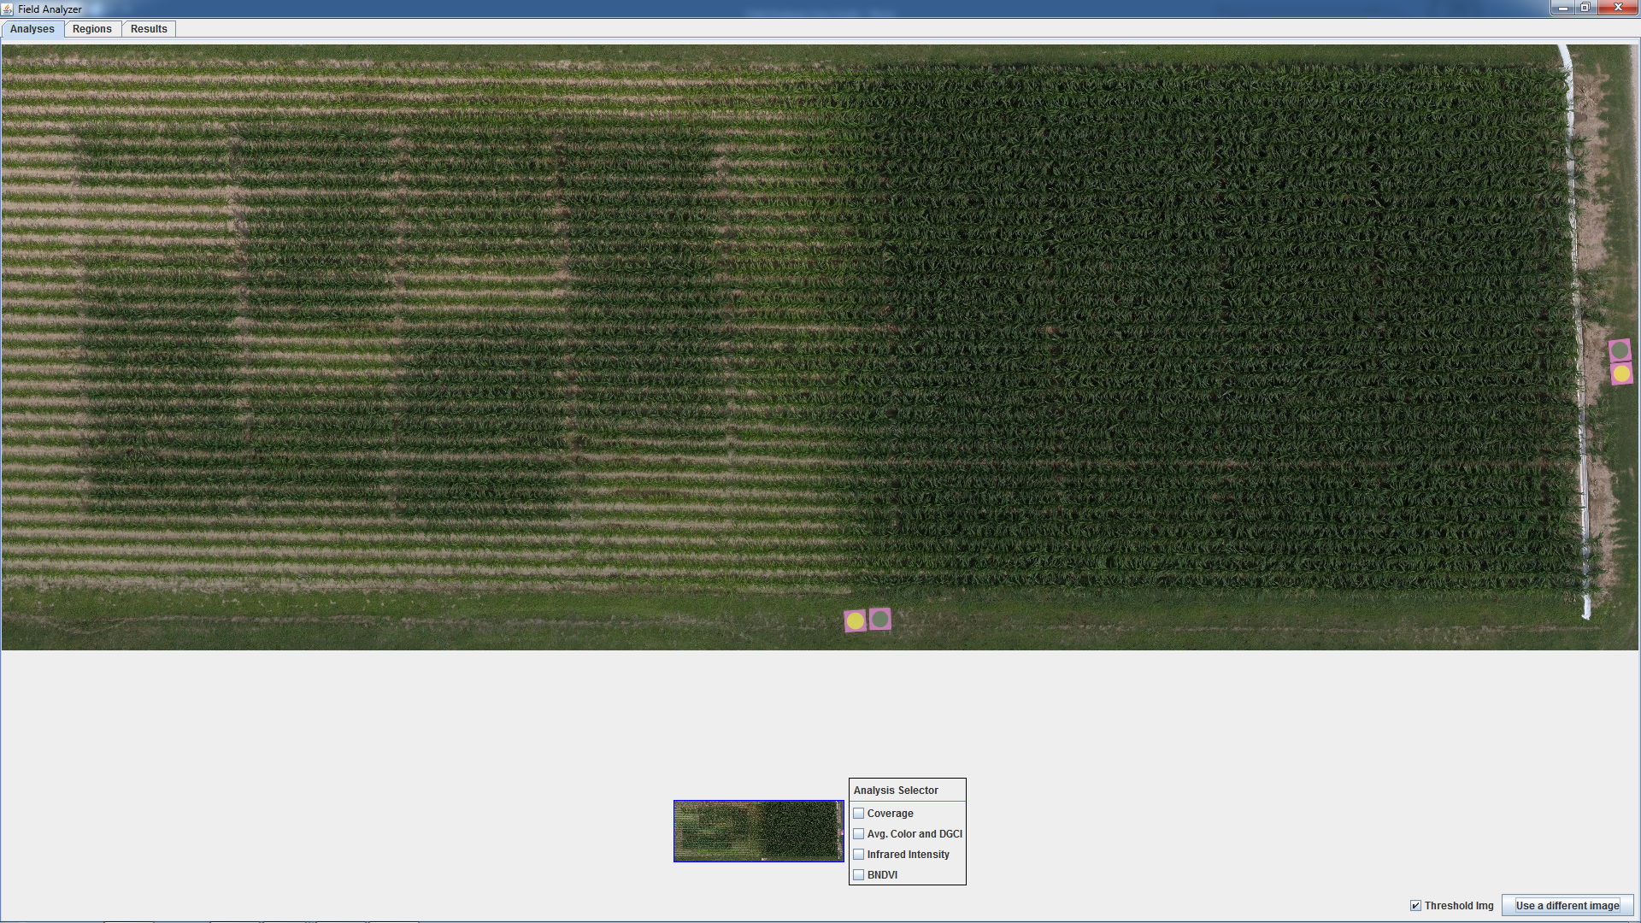
Figure 1.

By placing the mouse in the large image area, you can zoom in and out by rotating the mouse wheel. After zooming in, you can also click on the left-mouse button and holding the button down will allow you to drag from one side of the image to the other. The smaller image of the field at the bottom-center of the screen shows the entire field when you zoom in and has a blue rectangle around the region that is magnified. Left-clicking and holding the button down of the mouse on the smaller image at the bottom-center of the screen also allows you to drag the larger top image wherever you need to go.

There are three tabs in the upper left-hand corner of the screen and in Figure 1 this is currently set to ‘Analyses’. It is on this tab that you select the type of analysis you would like to conduct (i.e., canopy coverage, DGCI, IR, or NDVI).

Selecting the ‘Regions’ tab allows the user to define the plot areas to be analyzed, and selecting the ‘Results’ tab allows the user to review the results of the analysis up to that point.

Analyzing cover
Canopy coverage and DGCI can either be analyzed at the same time or independently since both types of analyses use normal, color images (i.e., RGB). We will describe the analysis of cover first and then describe the analysis of DGCI. Canopy coverage refers to the proportion of the crop area that is covered by leaves. Field Analyzer determines this in a given area by measuring the fraction of green pixels compared with the total of number of pixels, similar to the method described by Purcell (2000) using ground-based images. Therefore, the software need to be able to distinguish green leaves from the soil background.

Step 1. To begin the cover analysis, check the cover selection at the bottom and center of the screen (See Figure 1), and other menu options are populated as shown in Figure 2.

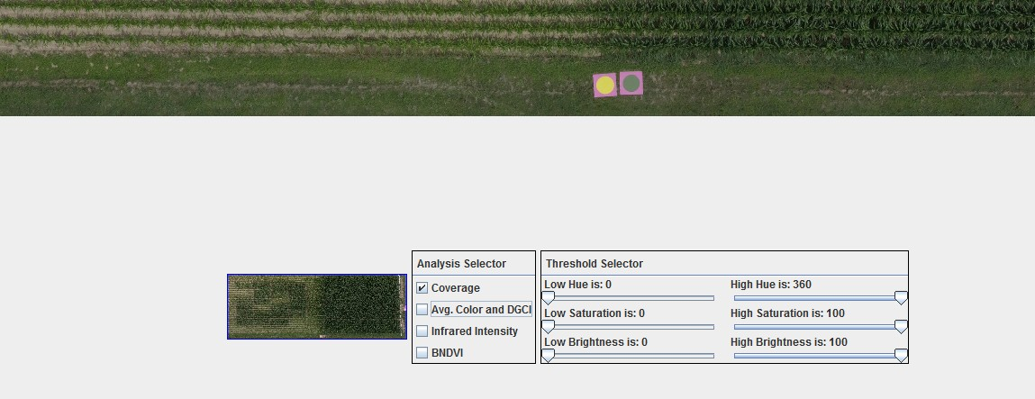
Figure 2.
Step 2. The sliders listed under ‘Threshold Selector’ will be used to identify green pixels from the soil background. By moving the sliders to the values shown in Figure 3, we have effectively identified the green pixels and eliminated the soil background. In the lower right-hand corner of Figure 3, is a box labeled ‘Threshold img’; toggling this check box allows the user to see the original image and the image identifying the pixels based upon the values from the sliders in the ‘Threshold selector’ settings.

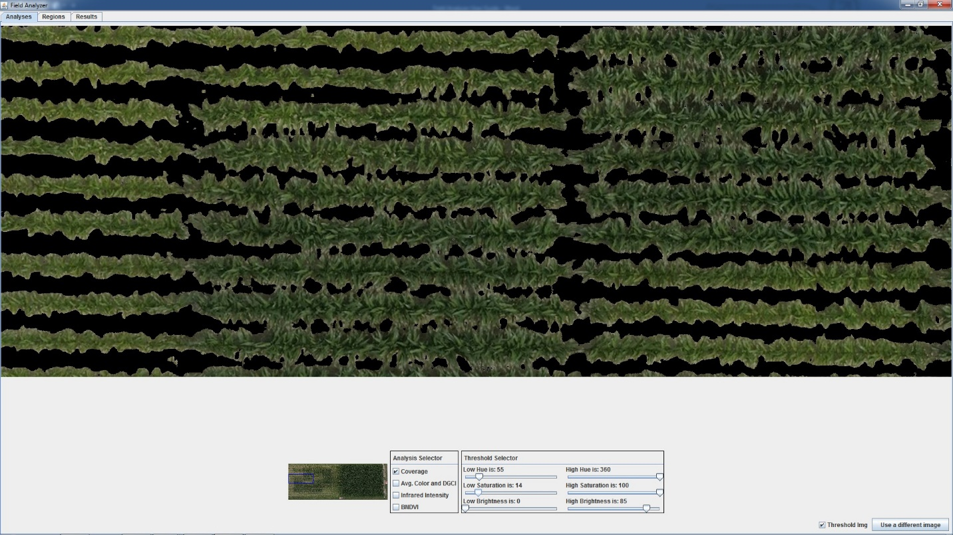
Figure 3.

Step 3. The next step is to select the ‘Regions’ tab in the upper right-hand corner of the screen. This screen allows us to define the areas to be analyzed. At the bottom of the screen (Figure 4) in the center, are options for ‘Region Type’; we will look first at ‘Place Grid’ by checking this box. By selecting the ‘Place Grid’ option, the user can define the number of plots to be analyzed by choosing the number of columns and rows of plots in the image. For example, in Figure 4, 6 rows and 4 columns are selected. To select the plots for analysis, double click on one corner where the plots are located and drag the mouse across the screen to other corner. As you drag the mouse across the screen, a grid (outlined in blue) will appear on screen (Figure 4). If your plots are not centered within the grid, you can hit the ‘Clear’ button at the bottom center of the screen and reposition the grid.
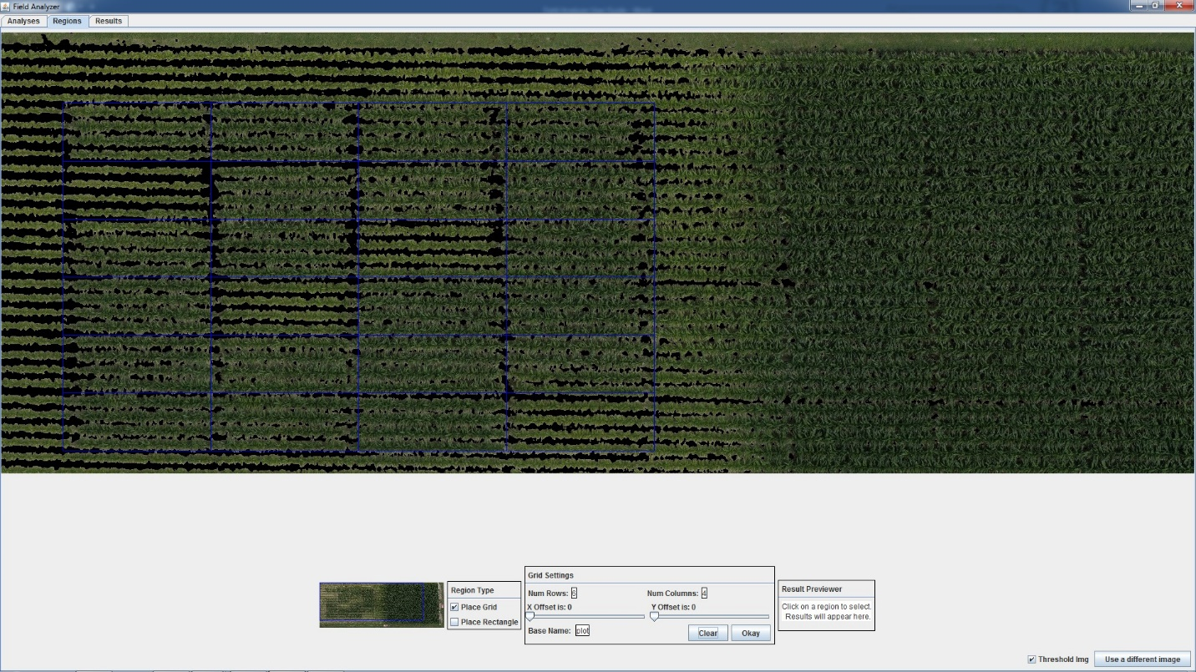
Figure 4.

Step 4. To remove the edge effects off the end of plots and between the plots, use the sliders in the box at the bottom center of the page. After removing the edge effects, hit the ‘Okay’ button.

The grid is now red, and clicking the mouse on an individual plot shows the values in the ‘Result Previewer’ box at the bottom center of the page (Figure 5). In this example, plot_01 has a coverage value of 0.732. Note that plots are automatically assigned number beginning at the top left and moving across the screen, to the second row on the top left (plot_05), and finishing at the bottom right portion of the screen (plot_24).

Step 5. To see the results in a tabular format, select the ‘Results’ tab at the top-left portion of the screen. A table is displayed showing the total number of pixels selected from each plot, the number of selected pixels (i.e., green pixels based upon the ‘Threshold Selector’ settings), and the coverage value (i.e. the fraction of green pixels). On the bottom right of the ‘Results’ tab is a button to ‘Save Results’; choosing this selection, allows the user to save the results in a csv format, which can be opened directly into a spreadsheet.

Alternative cover analysis. In some applications it may be easier to select individual areas in the field rather than using the grid function. This can be done by using the ‘Place Rectangle’ option that is located at the bottom center of the ‘Regions’ tab. To use this function, select the threshold settings as described in Step 2 and then double click on a corner of the area that you wish to analyze and drag the mouse over to the opposite corner and double click again. The results are automatically displayed in the ‘Results Previewer’ and are logged onto the ‘Results’ tab (Figure 5).

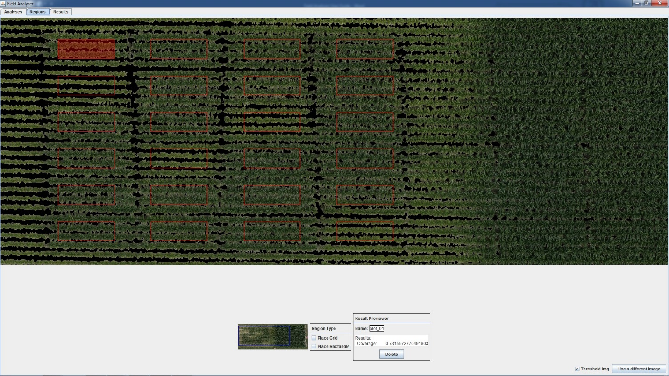
Figure 5.

Analyzing DGCI
The dark green color index (DGCI) was originally developed by Karcher and Richardson (2003) as a metric for turf quality, and DGCI is one of the measurements included in Turf Analyzer for ground-based images. The DGCI is a composite value of the hue, saturation, and brightness of an image that varies between 0 and 1 and is a measure of ‘greenness’ intensity. DGCI has also been used in corn (Rorie et al., 2010, 2011; Rhezali et al., 2018) and is closely associated with leaf N concentration. To standardize lighting conditions for aerial images, boards painted with yellow paint (DGCI=0.0733) or green paint (DGCI=0.5722) are placed at the edge of the field. The paint used on the boards are matched with X-rite reference paper having Munsell color values 6.7GY 4.2/4.1 for the green and 5Y 8/11.1 for yellow. A small sample of the X-rite paper can be taken to a hardware store to have paint mixed that matches the standard colors (note paint should have a matt finish, to decrease reflection). Field Analyzer uses the yellow and green standards in the images to correct for differences in lighting conditions or among cameras (Rorie et al., 2011). Samples of X-rite standards may be purchased for a nominal fee by contacting turfanalyzer@gmail.com.

Step1. Analysis of DGCI is similar to the analysis of canopy coverage. After selecting the image for analysis, you should select ‘Average Color and DGCI’ from the options at the bottom of the screen (Figure 1). Selection of the thresholds is similar to that described in Step 2 in the section on Analyzing Cover with one additional caution – when selecting the color thresholds, it is important that the color standards are not eliminated as you try to eliminate soil background. After selecting the option for ‘Average Color and DGCI’, you should also select ‘DGCI Standards Enabled’.

Step 2. When you check the box that enables DGCI Standards, a new ‘box’ comes up at that has a slider defining a radius and that has different values of DGCI for the green and yellow standards. To identify the yellow standard in the program, place the mouse in the center of the yellow standard and double click. You can increase the radius to cover more of the standard if you wish (Figure 6). Repeat this process with the green standard. If you have used different standard colors than the default values, these can be changed at this time.

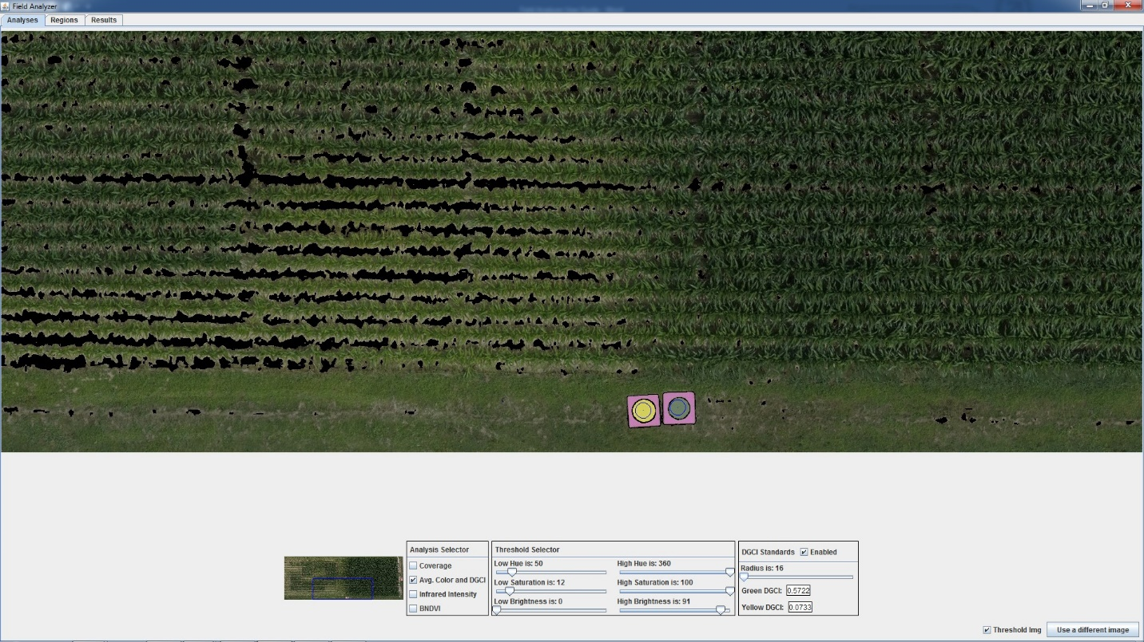
Figure 6.

Step 3. The remainder of the analysis is exactly the same as for Canopy Coverage. Follow Steps 3, 4, and 5 as described for Canopy Coverage.

Analyzing NDVI
The Normalized Difference Vegetation Index (NDVI) is one of the most widely used indices for evaluating crop growth and crop response to stress. NDVI is traditionally calculated as:
NDVI = (NIR-RED)/(NIR+RED), where NIR is the near-infrared reflectance (wavelengths >700 nm) and RED is the red reflectance. The NDVI that we report is slightly different and is based on the BLUE reflectance instead of the RED. We have elected to use this form of NDVI because it allows the use of NDVI from everyday digital cameras (e.g., https://event38.com/product/ndvi-camera-ngb-converted-canon-s110-camera/) that have been converted for measuring NDVI at a fraction of the cost of commercial units. Results from the NDVI analysis include average reflectance of NIR, BLUE, and GREEN channels for each plot, and a NDVI calculated as (NIR-BLUE)/(NIR+BLUE).

Step 1. Analysis of NDVI is similar to the analysis of canopy coverage and DGCI. After selecting the image for analysis, you should select ‘NDVI’ from the options at the bottom of the screen. After selecting NDVI, a slider comes up that allows you to select threshold values to include in the analysis. This is useful if you do not have complete ground cover and you wish to eliminate soil background and only evaluate NDVI of vegetation. Figure 7 shows an NDVI image of a turf experiment, and at the top of the figure is a road. By adjusting the NDVI threshold to 88, the soil background is eliminated, and any pixels below the threshold value would not be included in the NDVI value reported for a plot.

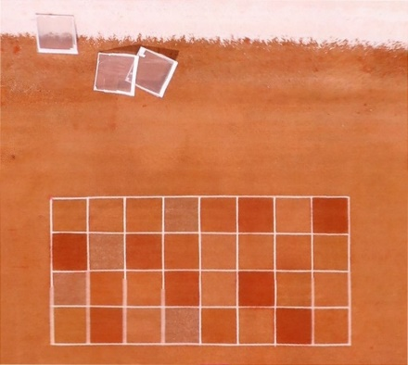
Figure 7. The image to the right is the original NDVI. The bottom image is from Field Analyzer after the NDVI threshold has been set to 88.
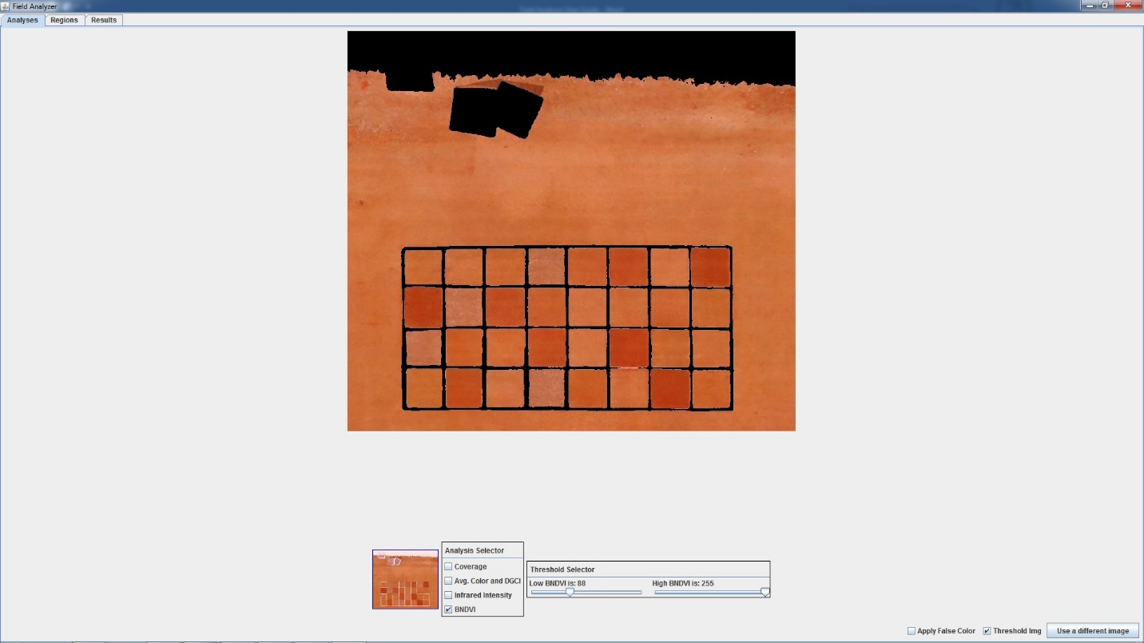

Step 2. Note that in the lower right hand portion of the screen (Figure 7) is an option to select “Apply False Color”. Checking this box converts the NDVI values to a scale that is more intuitive to interpret visually (Figure 8). In Figure 8, healthy plots are dark green and unhealthy or stressed plots are yellow. If we had not set the threshold to 88, the road and the screens in the image would appear as red in the false color.

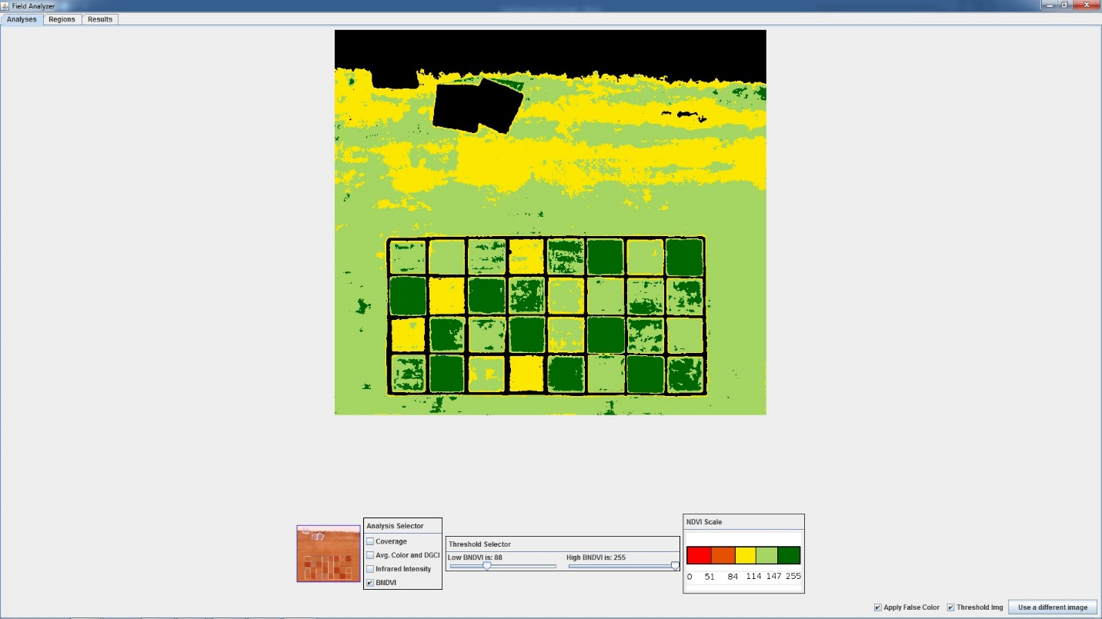
Figure 8.

Step 3. The remainder of the analysis is exactly the same as for Canopy Coverage. Follow Steps 3, 4, and 5 as described for Canopy Coverage.

Analyzing Infrared
Infrared (IR) images indicate the relative intensity of IR energy emitted by the crop. Crops that are actively growing are also transpiring, which cools the crop compared to a crop that is stressed and not transpiring as readily. Ideally, IR measurements should be made in full sun with little or no wind. Most IR camera systems have settings to record in grey-scale with values ranging from 0 (cool) to 255 (hot) with the temperature range over these 256 different shades of grey depending upon the camera model and sensitivity. The IR analysis by Field Analyzer provides the average value of pixels within a plot, and these values represent relative temperature differences among plots or treatments (Bai and Purcell, 2018).

Step 1. Select an IR image from the Field Analyzer menu and check the box indicating that you wish to analyze ‘Infrared Intensity’. Sliders appear after selecting Infrared Intensity that allows you to eliminate ‘hot spots’ such as soil surface if there is an incomplete canopy.

Step 2. The remainder of the analysis is exactly the same as for Canopy Coverage. Follow Steps 3, 4, and 5 as described for Canopy Coverage. Figure 9 shows the IR analysis of a turf experiment after the grid has been placed over the plots and the edge effects removed.

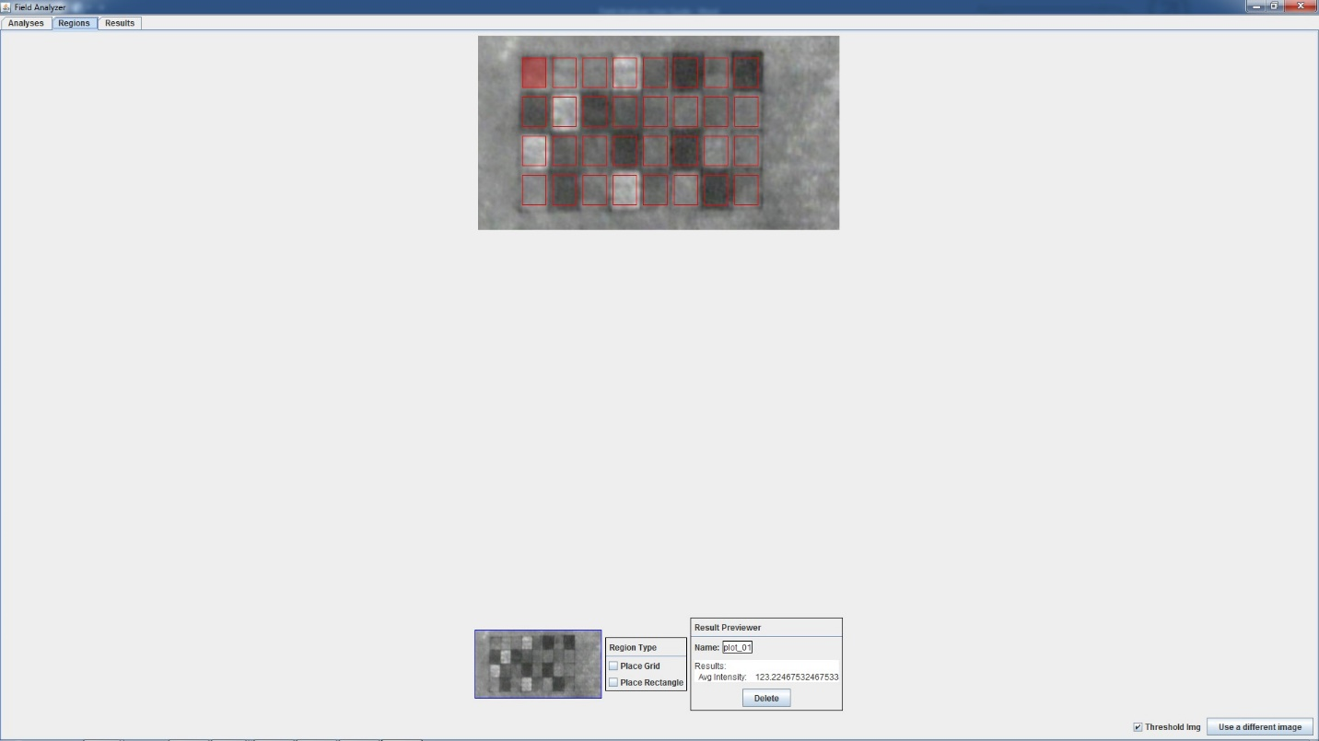
Figure 9.

References:
Bai, H. and L.C. Purcell. 2018. Aerial canopy temperature differences between fast- and slow-wilting soybean genotypes. J. Agron. Crop Sci. DOI: 10.1111/jac.12259.
Karcher, D. E., and M. D. Richardson. 2003. Quantifying turfgrass color using digital image analysis. Crop Sci. 43:943-951.
Purcell, L.C. 2000. Soybean canopy closure and light interception measurements using digital imagery. Crop Sci. 40:834 837.
Rhezali, A., L.C. Purcell, T.L. Roberts, and C. Greub. 2018. Predicting N requirements for maize with the Dark Green Color Index under experimental conditions. Agron. J. 110:1-7.
Rorie, R.L., L.C. Purcell, M. Mozaffari, D.E. Karcher, C.A. King, M.C. Marsh, and D.E. Longer. 2010. Association of “greenness” in corn with yield and leaf nitrogen concentration. Agron. J. 103:529-535.
Rorie, R.L., L.C. Purcell, D.E. Karcher, and C.A. King. 2011. The assessment of leaf nitrogen in corn from digital images. Crop Sci. 51:2174-2180.

